Pytorch-geometric 库 安装记录

Hub 地址<https://github.com/rusty1s/pytorch_geometric>

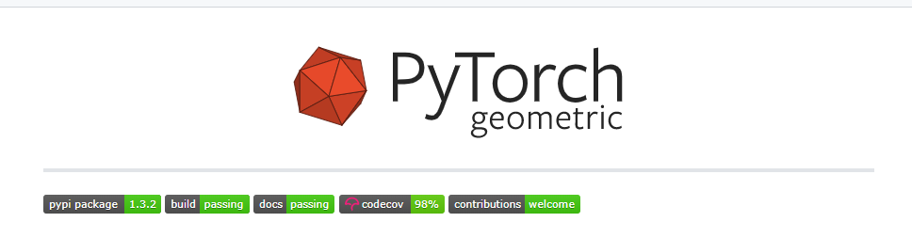

|  |  |
| --- | --- |
| 依赖库 | Hub地址 |
| torch Scatter | <https://github.com/rusty1s/pytorch_scatter> |
| torch-sparse |  |
| torch-spline-conv |  |
| pip install torch-cluster  (之后发现的) |  |
| torch-geometric |  |

# 1.安装torch-scatter

若直接pip install ， 将出现如下错误：

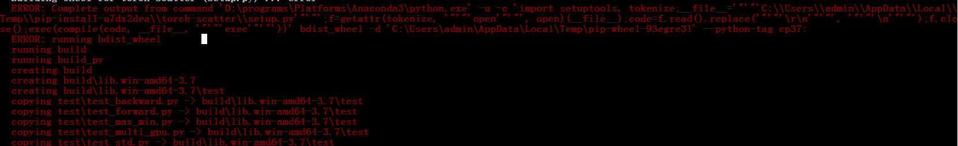

|  |
| --- |
| ERROR: Complete output from command 'D:\programs\Platforms\Anaconda3\python.exe' -u -c 'import setuptools, tokenize;__file__='"'"'C:\\Users\\admin\\AppData\\Local\\Temp\\pip-install-u7dx2dea\\torch-scatter\\setup.py'"'"';f=getattr(tokenize, '"'"'open'"'"', open)(__file__);code=f.read().replace('"'"'\r\n'"'"', '"'"'\n'"'"');f.close();exec(compile(code, __file__, '"'"'exec'"'"'))' bdist_wheel -d 'C:\Users\admin\AppData\Local\Temp\pip-wheel-93egre3l' --python-tag cp37:  ERROR: running bdist_wheel |

根据<https://github.com/rusty1s/pytorch_geometric/issues/362>

几乎相同配置：

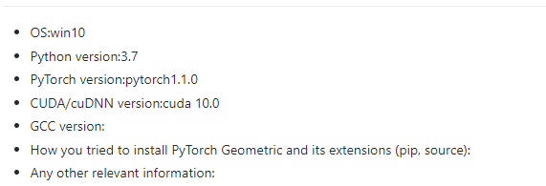

措施：self-build, git clone 之后，找到setup.py

，根据issue的建议，修改setup.py:

|  |
| --- |
| if platform.system() != 'Windows':  extra_compile_args += ['-Wno-unused-variable']  else:  extra_compile_args=["-g", "-stdlib=libc++", "-std=c++11"] |

Step2.

报错如下：

|  |
| --- |
| D:/programs/Platforms/Anaconda3/lib/site-packages/torch/include\c10/util/flat_hash_map.h(1379): error C3203: “templated_iterator”: |

Pytorch 内部问题，根据 <https://github.com/pytorch/pytorch/issues/19156>

尝试在对应位置加入宏定义：

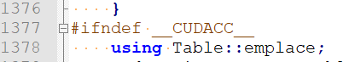



Step3.

再次编译,仍然出错：



具体报错：

|  |
| --- |
| flat_hash_map.h(1506): error: nonmember operator |

发现并没有类似错误，回溯到上一步，重新理解<https://github.com/pytorch/pytorch/issues/19156>

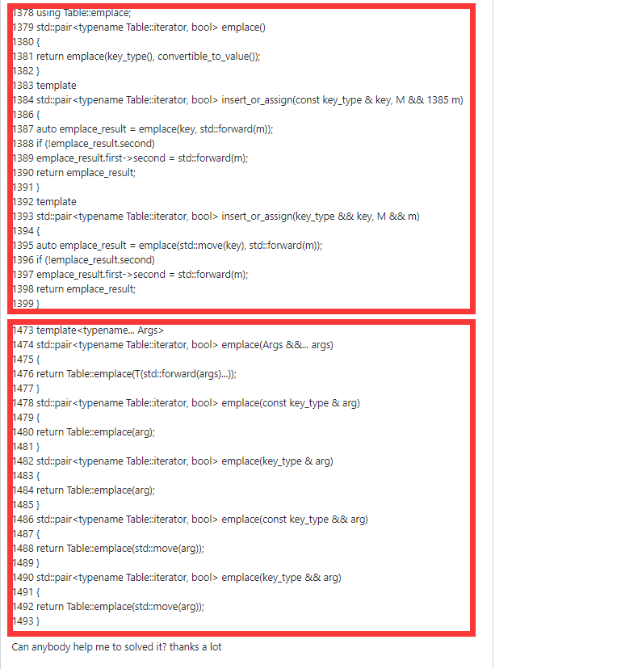

应该两段分别加入宏定义









成功。



插曲：第一次执行example时：

|  |
| --- |
| import torch  from torch_scatter import scatter_max |

发现报错：

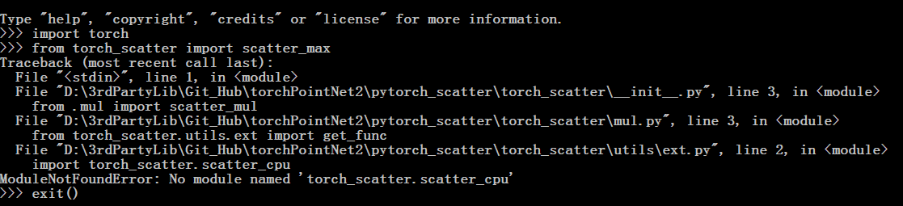

删除了build 文件夹之后发现仍然如此，于是直接到下一步test

|  |
| --- |
| python setup.py test |

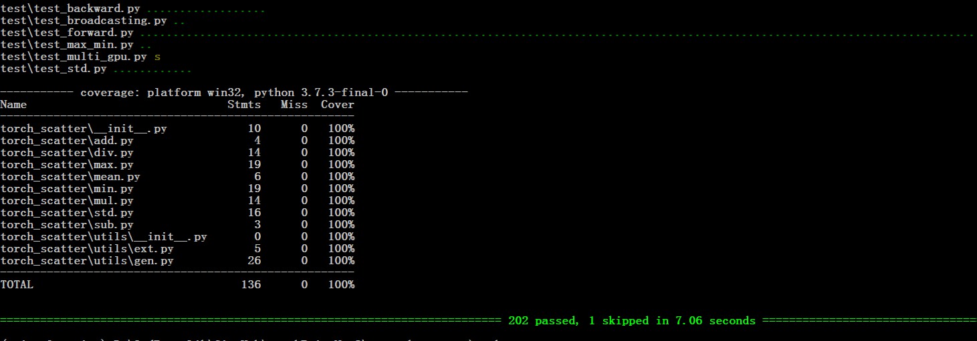

看起来一切正常，再次尝试import 测试：

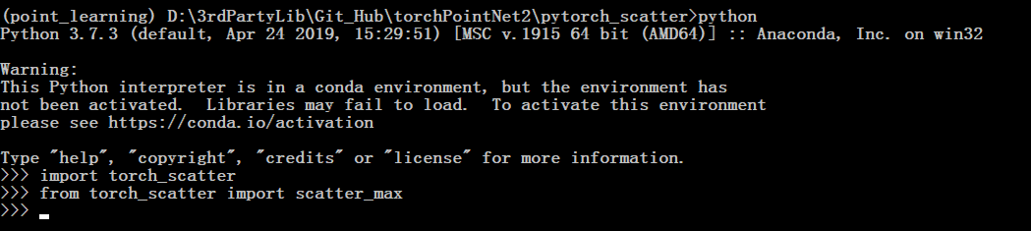

发现已经修复。

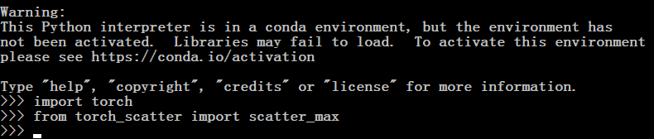

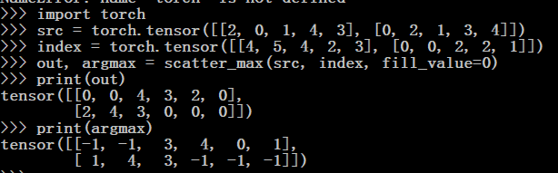

# 2.安装 torch-sparse

|  |
| --- |
| pip install --verbose --no-cache-dir torch-sparse |

先尝试直接pip, 发现可行：

找到 <https://github.com/rusty1s/pytorch_sparse> 的测试：

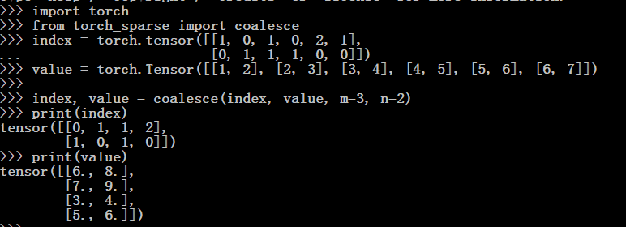 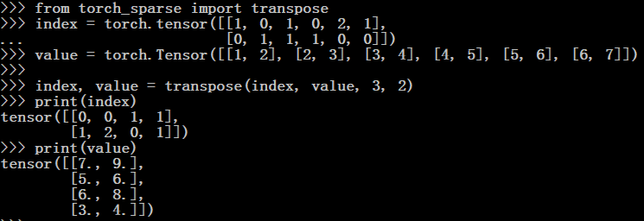

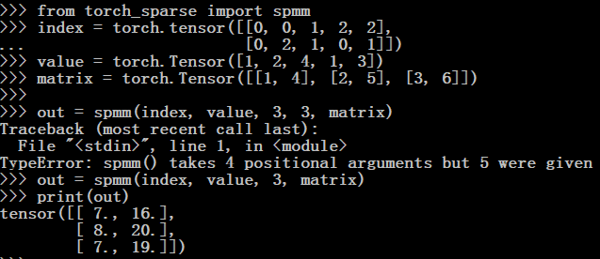 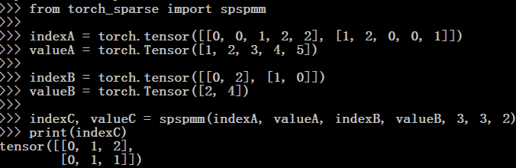

# 3.安装torch-spline-conv & torch-cluster

|  |
| --- |
| pip install torch-spline-conv -i <https://pypi.tuna.tsinghua.edu.cn/simple>  pip install torch-cluster |

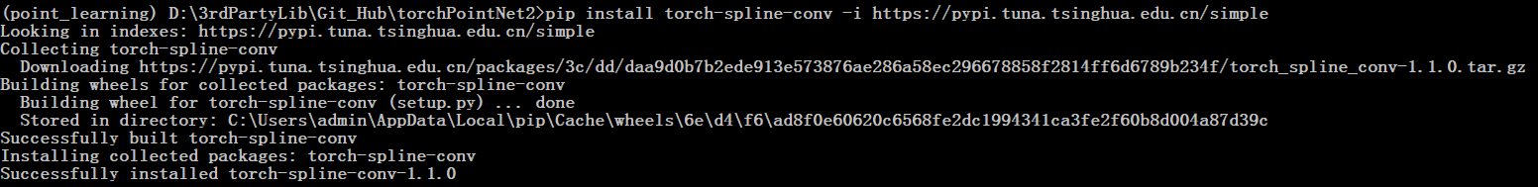

# 4. 正式安装 torch-geometric

|  |
| --- |
| pip install torch-geometric -i https://pypi.tuna.tsinghua.edu.cn/simple |

